Objective
- To understand the concept of loops in C programming.
- To practice repetitive tasks using while, do-while and for loops.
- To apply conditional statements inside loops.
- To develop logical thinking by solving programming problems.

Software Used
- CodeBlocks IDE / Dev C++
- C Programming Language
Task 1: Café Menu using do-while Loop
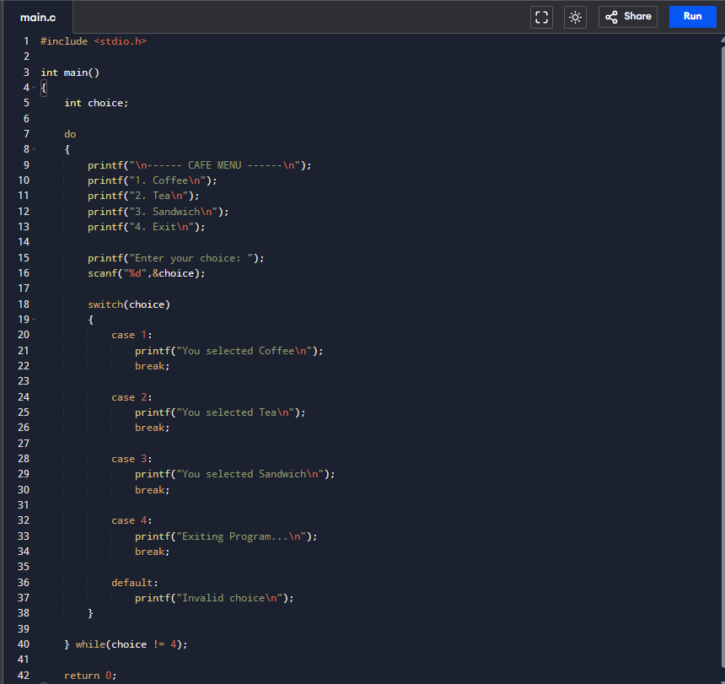
Code
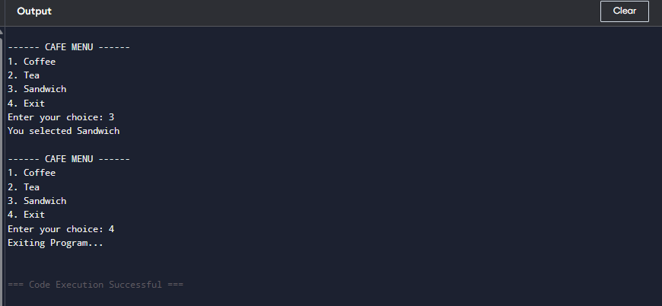
Conclusion of Task 1
In this task we implemented a do-while loop to repeatedly display a café menu until the user chooses to exit. The switch statement was used to handle different menu options. The do-while loop ensures the menu appears at least once, making it suitable for menu-driven programs.
Task 2: Product of Odd Numbers
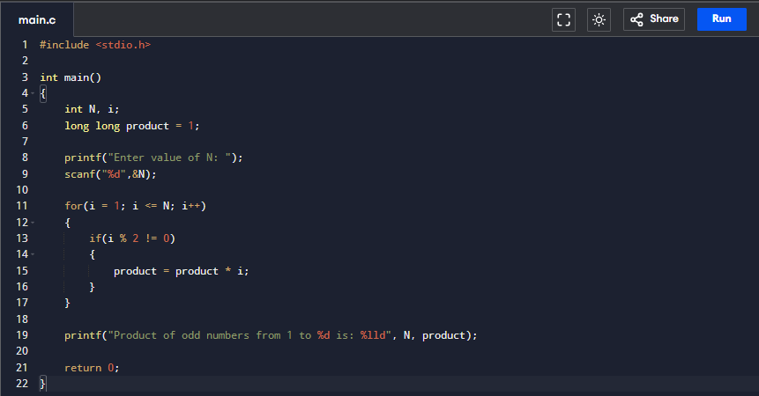
Code
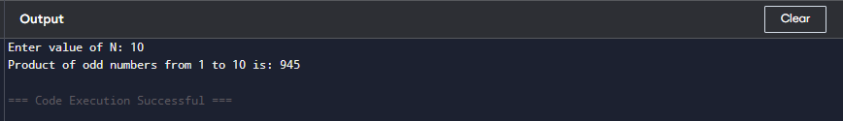
Conclusion of Task 2
This program calculates the product of all odd numbers from 1 to N using a for loop. The condition i % 2 != 0 checks whether a number is odd. This task helped in understanding how loops can perform repetitive calculations efficiently.
Task 3: Separate Even and Odd Numbers
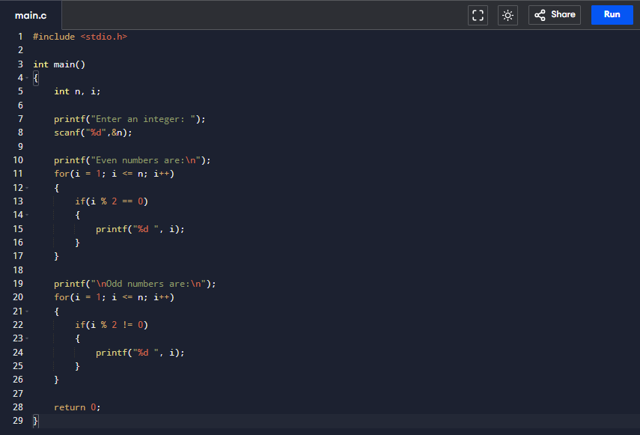
Code
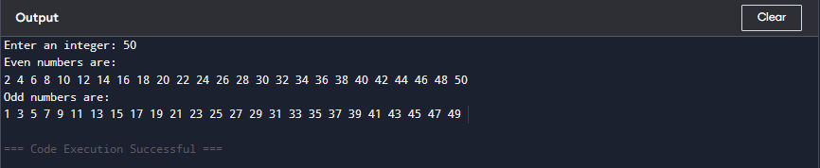
Conclusion of Task 3
This task separates even and odd numbers from 1 to N using loops and conditional statements. It helped us understand the use of modulus operator (%) and how loops can process numbers sequentially.

Critical Analysis
This lab provided practical experience with loops in C programming. The tasks demonstrated how repetitive operations can be handled efficiently using while, do-while, and for loops. The café menu program showed how loops are used in interactive applications, while the other tasks illustrated mathematical computations and logical decision-making.
Through these exercises, we improved our understanding of control structures, conditional statements, and iteration techniques. Overall, this lab strengthened our problem-solving skills and helped us understand how loops are used in real programming scenarios.

Post-Lab Task
Problem
Take an integer N from the user.
- If N is prime, calculate factorial of N.
- If N is not prime, calculate the sum from 1 to N.
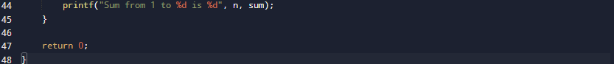
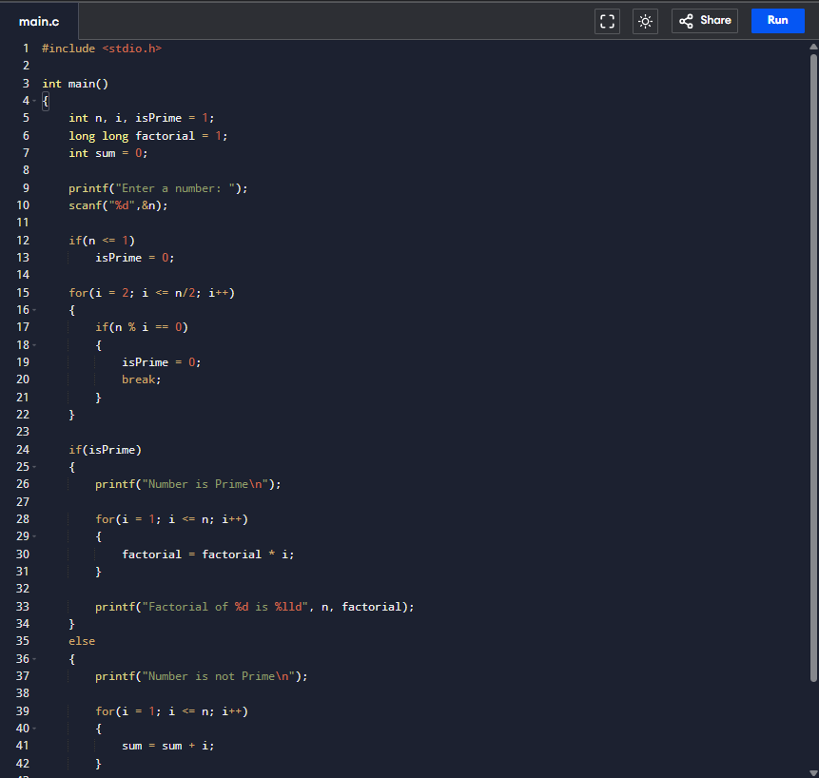
Code

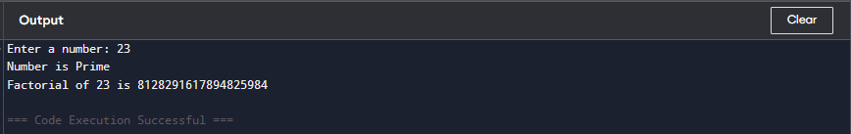
Conclusion of Post-Lab
This program checks whether a number is prime using a loop. If it is prime, the program calculates its factorial; otherwise, it calculates the sum of numbers from 1 to N. This task combined loops, conditions, and mathematical logic in a single program.

